Software Requirements
Specification
for
TAAL VISTA’S HOTEL GUESTROOM INSPECTION SYSTEM
Version 1.0 approved
Prepared by
Chantal Saldivar
Kevin Magno Barrion
Eligio Balao III

January 8, 2018
Copyright © 1999 by Karl E. Wiegers. Permission is granted to use, modify, and distribute this document.

Software Requirements Specification for <Project> Page ii

Table of Contents
Table of Contents ii
Revision History ii
1. Introduction 1
1.1 Purpose 1
1.2 Document Conventions 1
1.3 Intended Audience and Reading Suggestions 1
1.4 Product Scope 1-2
1.5 References 2
2. Overall Description 2
2.1 Product Perspective 2
2.2 Product Functions 2-3
2.3 User Classes and Characteristics 3-4
2.4 Operating Environment 5
2.5 Design and Implementation Constraints 5
2.6 User Documentation 6-15
2.7 Assumptions and Dependencies 16
3. External Interface Requirements 16
3.1 User Interfaces 16-17
3.2 Hardware Interfaces 17
3.3 Software Interfaces 17
3.4 Communications Interfaces 18
4. System Features 18
4.1 System Feature(s) 19-23
5. Other Nonfunctional Requirements 23
5.1 Performance Requirements 23
5.2 Safety Requirements 23
5.3 Security Requirements 23
5.4 Software Quality Attributes 24
5.5 Business Rules 24
6. Other Requirements 24-25
Appendix A: Glossary 25
Appendix B: Analysis Models 26
Appendix C: To Be Determined List 26

Introduction

Purpose
The developers aim to convert Taal Vista Hotel's current guest room inspection system by taking the client's requirements and developing a proposed system which includes (1) creating a mobile application for the current paper-based guest room inspection process, (2) implementing Quick Response Code (QR Code) stamps for automated recording of the inspector's room inspection time-in and time-out, as well as (3) generating room inspection reports from every completed room inspection. The room inspection reports would include the completed guest room inspection checklist, the recorded inspector's time-in and time-out time stamps, the current date, and the room's number.
The goal of the proposed system is to give less physical tasks for the Housekeeping department to handle. The proposed system will have a mobile application to be the interface between the user and the system. The proposed hotel guest room inspection system should be able to generate, receive, and forward guest room inspection reports within the housekeeping department. Furthermore, the goal of the proposed system is to lessen the manual tasks for the Housekeeping staff.

Document Conventions
When writing the Software Requirements Specitfication(SRS), the developers assured it’s understandable and informative. And also in this document, the font is Calibri and the font size is 12. Sections and sub-section heading which are used to label are in bold-faced text to be recognizable. Every requirement statement in this document are has its own priority.

Intended Audience and Reading Suggestions
The document is to be read by the project developers, Taal Vista’s management and the define users such as housekeeping staff, housekeeping supervisors and the housekeeping manager.

Product Scope
The i-spector mobile checklist app would only be accessible to housekeeping supervisors who’s responsible for the day-to-day inspection. What the i-spector app can do is to receive the housekeeping report from the housekeeping system and make it a basis for the room inspection checklist that can be created and customized with the used of the i-spector app.The Housekeeping Manager is the only one who could receive the inspection report through a webpage for the full details of each inspected rooms.

References
•Knowcross. Retrieved from http://www.knowcross.com/know-inspection/
•Amadeus. Retrieved from https://www.amadeus-hospitality.com/amadeus-service-optimization/hotsos-housekeeping/
•Hotel Service Pro. Retrieved from http://www.hotelservicepro.com/
•InspectionApps. Retrieved from http://www.inspectionapps.com/

Overall Description

Product Perspective
The system which the team is developing would serve as a replacement to Taal Vista’s current Inspection System. Their current system is being done manually using paper and pen. So, the team would provide a digitized system. System which is a module of a single system for taal vista.
This system is consisting of two parts: one is for mobile application and the other one is for web portal. The function of the mobile application is to inspect different rooms that has been cleaned by the housekeeping staff which will be stored to a database while the web portal will be used for managing the information for the whole system.

Product Functions
2.2.1 Login
- To login to the system, the hotel’s housekeeping staff and housekeeping inspector must first create an account to enter to the system. Both users has different privilege but the main actor of the app is the housekeeping inspector.
2.2.2 Room Color Status
- The system has a room color status which goal is to give an indication to the housekeeping inspection about the rooms ready to be inspected.
2.2.3 Qr code
- The i-spector app has a QR code stamp for automated recording of housekeeping supervisor’s time-in and time-out.
2.2.4 Checklist
- The system has a default checklist for the two types of rooms, the Suite and Non-suite Rooms. Inside the checklist are the different room areas to be inspected.
- The checklist has also a remark section.
2.2.5 Submit housekeeping report
- The i-spector system can generate an inspection report through a web portal that will only be accessed by the housekeeping manager

User Classes and Characteristics
Housekeeping inspectors require no formal education. Housekeeping inspectors examine rooms prior to guests arriving and conduct inspections upon their departure to assess if any defect occurred. Housekeeping inspectors must possess excellent organizational skills and be detail-oriented. Being able to work in a fast-paced environment, make sound decisions and utilize good judgment benefits people in this position. They need to be able to multi-task, establish priorities and communicate well with others. Having knowledge of computers and software programs, such as Excel, PowerPoint and Word, helps with this job. Employers expect housekeeping inspectors to be familiar with housekeeping standards and current practices.

Operating Environment
Programming Language
Python
Python is an interpreted, object-oriented programming language that has gained popularity because of the language’s clear syntax and easy to read aspect.
Java
Java is a general-purpose computer programming language that is concurrent, class-based, object-oriented, and specifically designed to have as few implementation dependencies as possible.
Hardware Requirements
Android Device
A handheld device that will be utilized by the housekeeping supervisor during his or her room inspection procedures.
Wifi
To be used on different purposes such as data transmission necessary for the system to work.
Computer
An electronic device that will be used for organizing different reports that come from the web server.
Software Requirement
Android Studio
is the official integrated development environment (IDE) for Google's Android operating system, built on JetBrains' IntelliJ IDEA software and designed specifically for Android development.
- Operating System – Windows 10
- Database - Firesebase

Design and Implementation Constraints
2.5.1 timing requirements
- Clicking of every functional button in the system should only take one click
- Response time should only take 5-6 secs.
2.5.2 memory
- Corsair Memory 4GB (1x4GB) DDR4 SODIMM 2133MHz
2.5.2 Database
- firebase shall be used
2.5.3 language requirements
- English as the only language that should be used

2.5.4 Security
- Housekeeping inspector should have an authorized account before he can access the i-spector system.
- Housekeeping manager are the only authorized person who can view the web portal

User Documentation
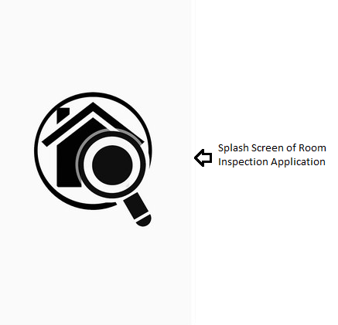
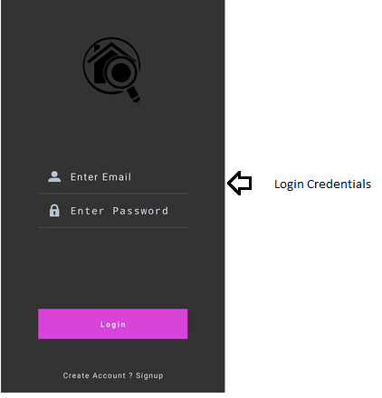
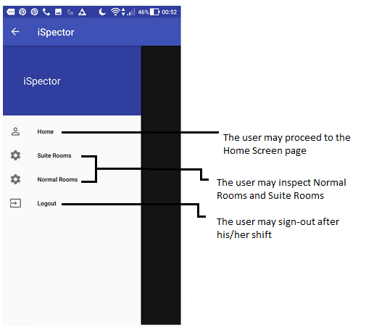’
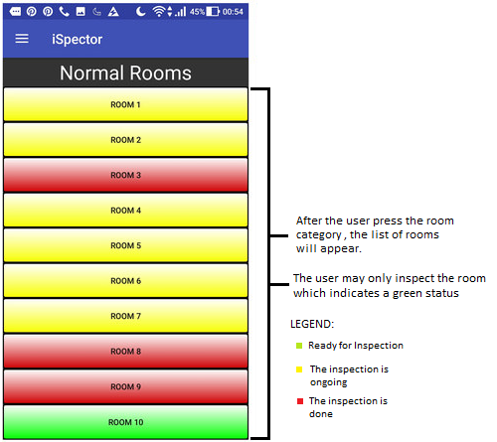
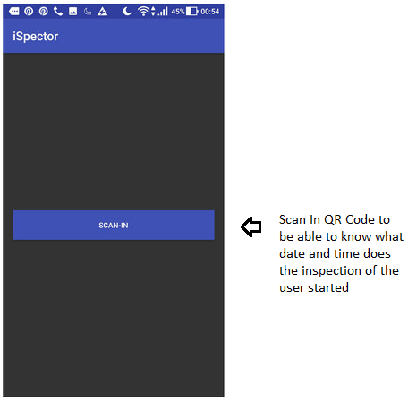
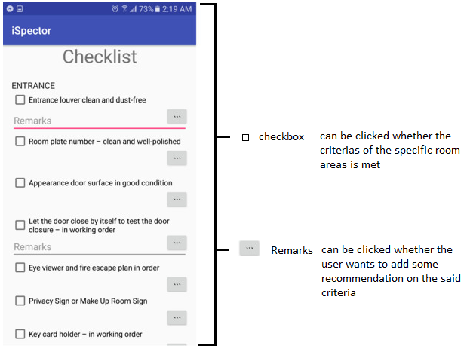
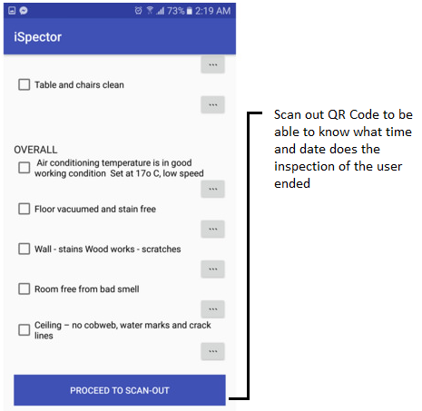

ROOM INSPECTION SYSTEM WEBSERVER
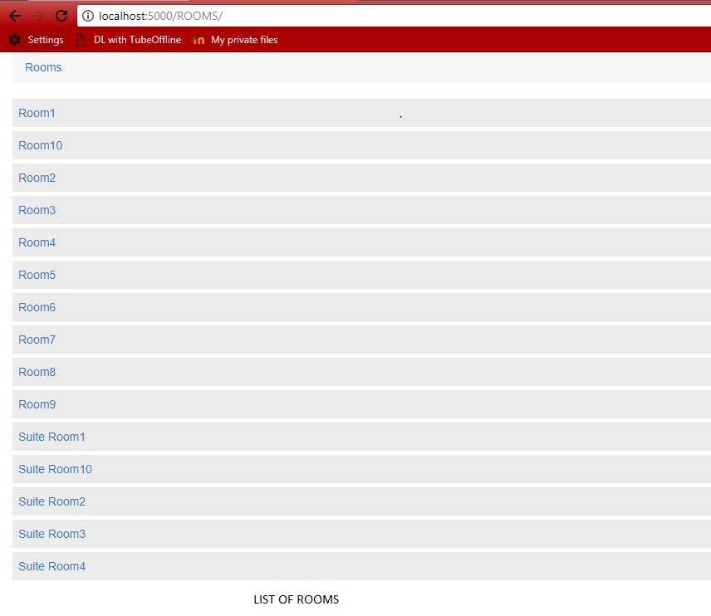
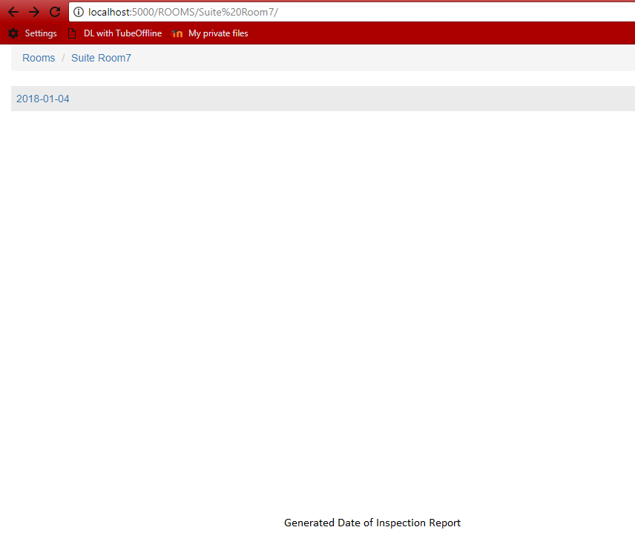
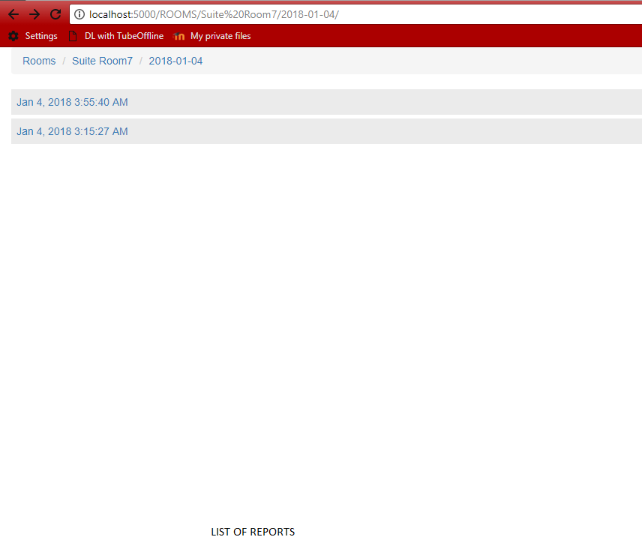

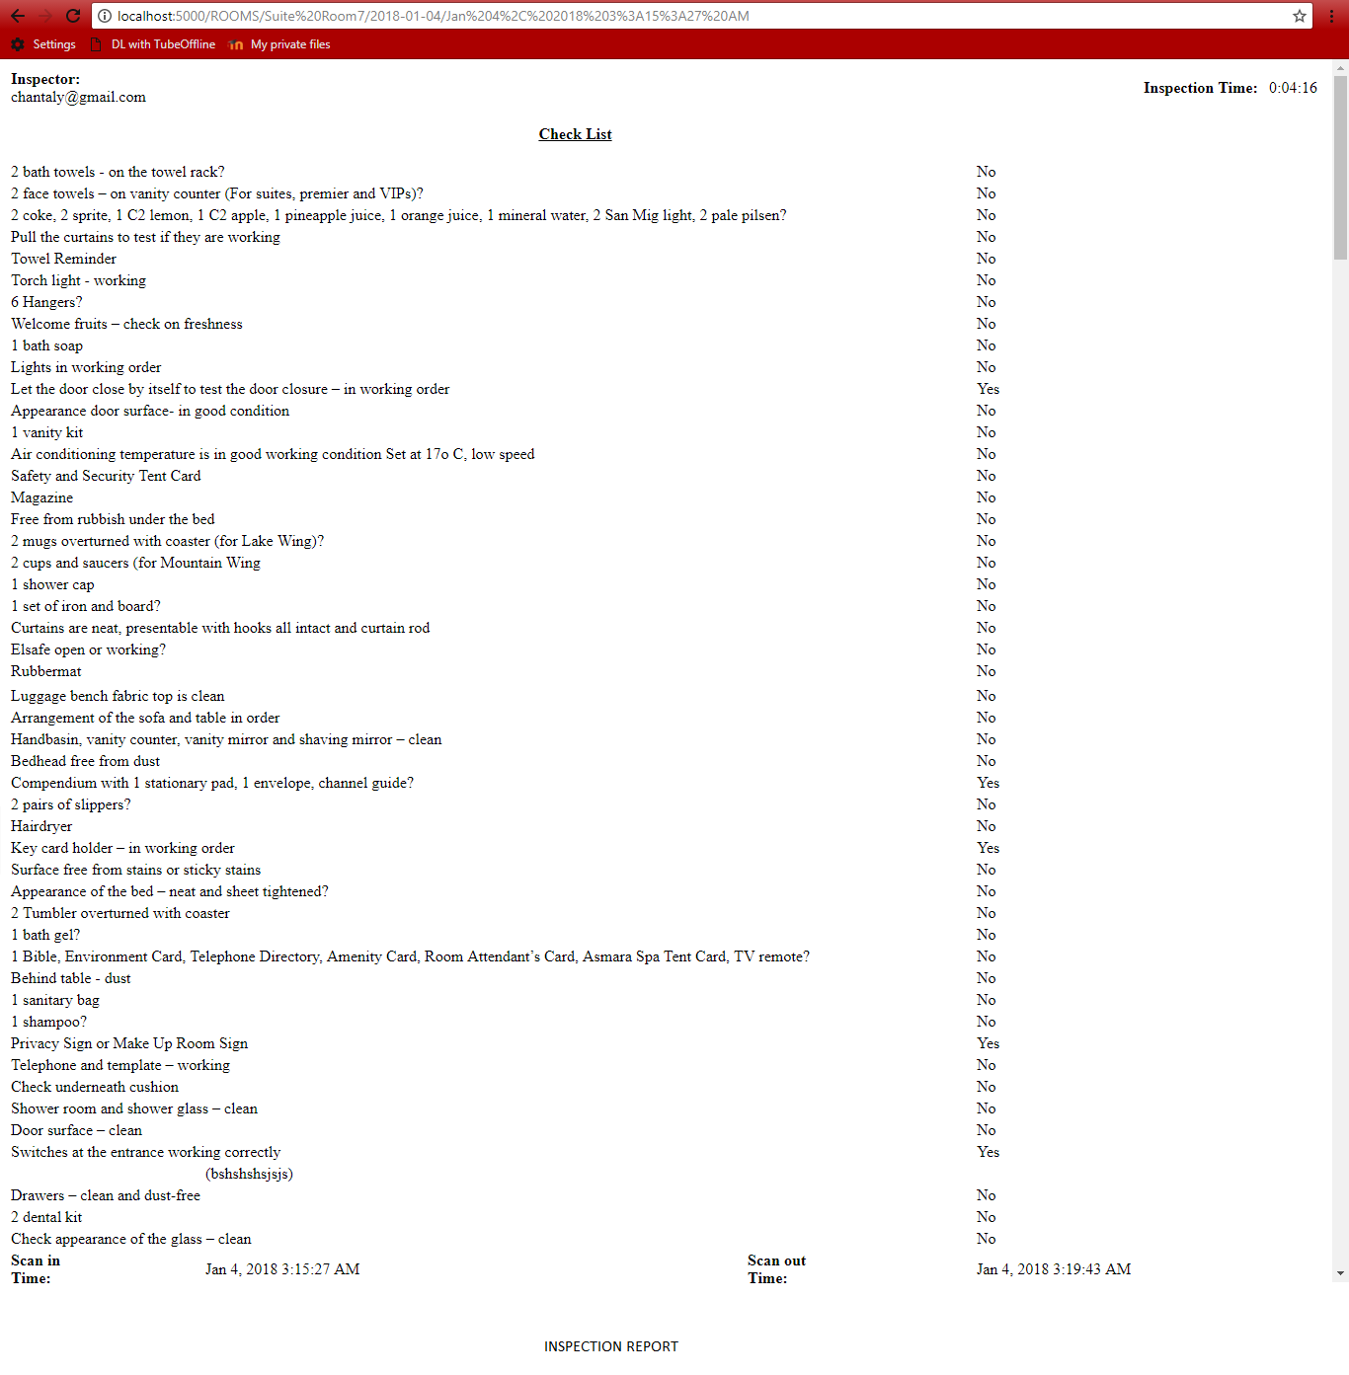

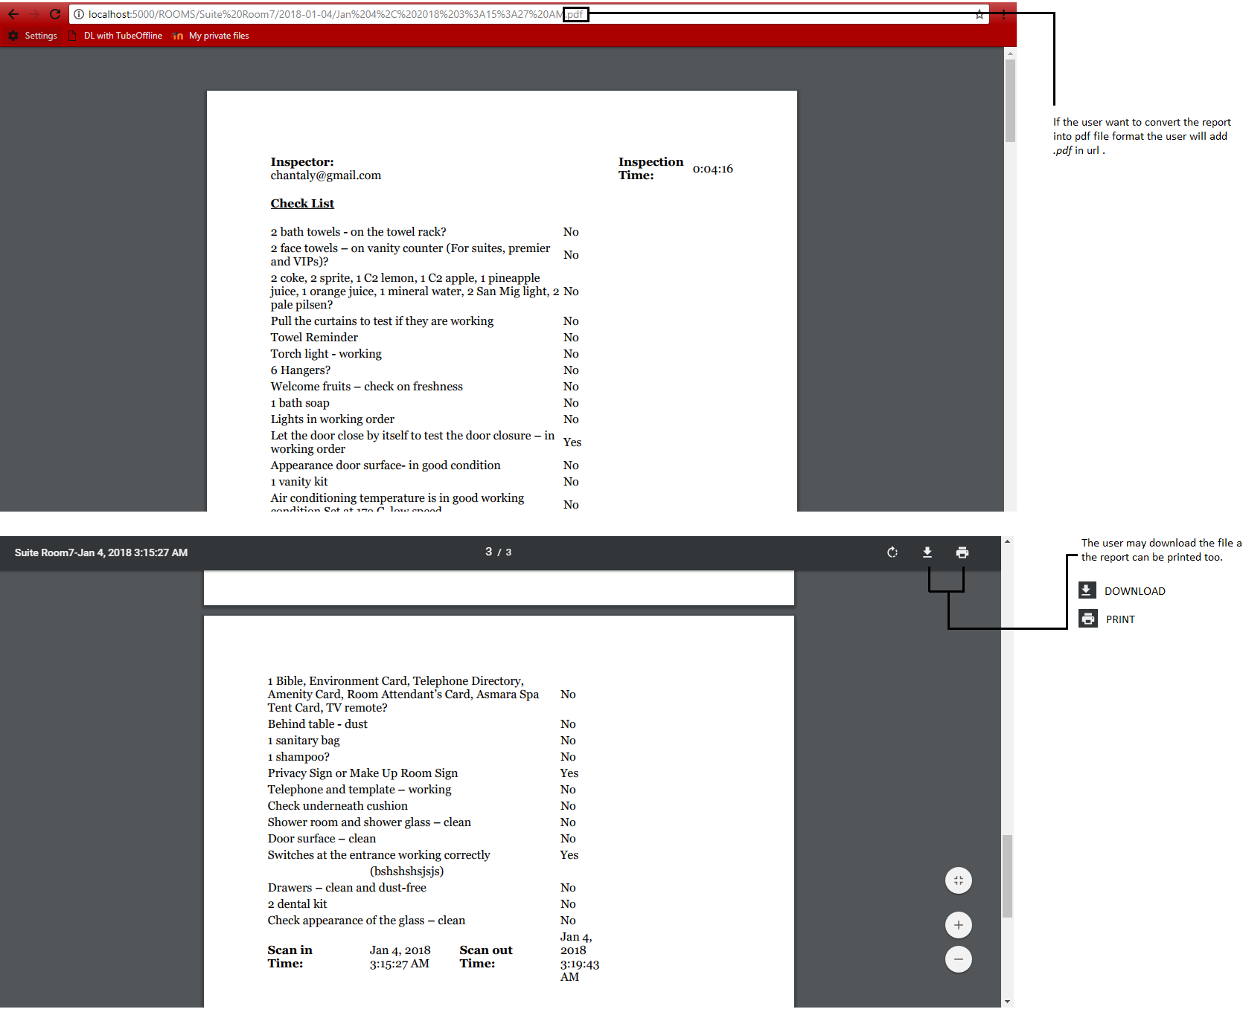
sReport converted to pdf

Assumptions and Dependencies
For the developers to conceptualize and develop iSpector, they had to assume everything that their client’s representative had not mentioned.

External Interface Requirements

User Interfaces
For the mobile application screenshots, you may refer to user documentation above. Android studio is the software used for the mobile app.
For the web interface here are the details:
you need to install python32 bit with its dependencies to integrate the server.
SETUP COMMANDS
Step 1: Create a virtual env
command: virtualenv --python=C:\Python34\python.exe (name of the env)
Step 2: find the kevsenv folder and put inside the server final folder
Step 3: Then activate
command: cd C:\Users\Chanty\Desktop\iSpector_ServerFinal\kevsenv\Scripts
command: activate
command: cd C:\Users\Chanty\Desktop\iSpector_ServerFinal\
Step 4: Install flask, weasyprint,flask-weasyprint
commands:
pip install flask
pip install weasyprint
pip install flask-weasyprint
To run the server
Step 1:set FLASK_APP=app.py
Step 2:set FLASK_DEBUG=1
Step 3:flask run
Step 4: go to your web browser and type "localhost:5000/ROOMS/"

Hardware Interfaces
- Smart Phone – The smart phone’s android version should be Marshmallow (Android 6.0) to use iSpector) and it should have at least a 3000mAh battery for it to last for a day. These specifications will guarantee the user that the phone will be efficiently enough to run iSpector.
- Computer – These specifications should be met to maximize its performance:
-CPU
AMD - Ryzen 3 1200 3.1GHz Quad-Core Processor
-MOTHERBOARD
ASRock - AB350M Micro ATX AM4 Motherboard
-MEMORY
Corsair Memory 4GB (1x4GB) DDR4 SODIMM 2133MHz
-STORAGE
Western Digital - Caviar Blue 1TB 3.5" 7200RPM Internal Hard Drive
-CASE
Any ATX Case
-POWER SUPPLY
Corsair - CX (2017) 450W 80+ Bronze Certified ATX Power Supply
-WIRELESS NETWORK ADAPTER
TP-Link - TL-WN881ND PCI-Express x1 802.11b/g/n Wi-Fi Adapter
-OPERATING SYSTEM
Microsoft - Windows 10 Home OEM 64-bit

Software Interfaces
- The inspection system should connect to housekeeping system to identify what room is ready for inspection.
- Both system should also be connected to a web server for the storing of data.

Communications Interfaces
- The python with flask with a library which is called pyre-base will be used to integrate the web. Data will be coming from the firebase.

System Features

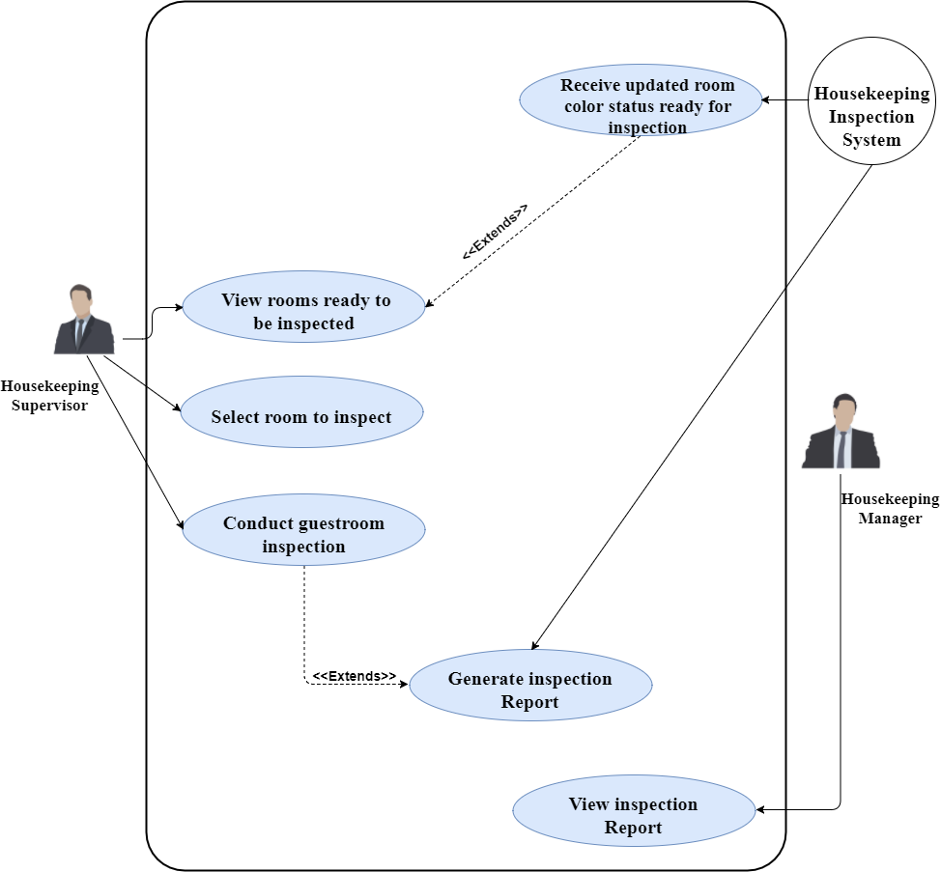

System Features

4.1 Use case name and identifier – Receive updated room color status ready for inspection(U1)

4.1.1 Objective- The housekeeping system will update room color status ready for inspection and the purpose of the first use case is to receive the updated room color status.
4.1.2 Priority – This requirement is a high priority.
4.1.3 Actor – Inspection Sytem.
4.1.4 Flow of events
4.1.4.1 Basic Flow
4.1.4.1.1 Authorized Housekeeping staff will login to the system.
4.1.4.1.2 Housekeeping staff will then choose what the type of room to be cleaned.
4.1.4.1.3 Before the housekeeping staff enter the room, the color status of the room is Red. When he scan Qr code for time in, it will change to yellow and if its done and Scan out was performed, the color will change to green.
4.1.4.1.4 The color green room status signifies that the room is ready to be inspected.
4.1.5 Notes/Issues – Use case No.1 is followed by Use Case No.2

4.2 Use case name and identifier – View Rooms ready for inspection (U2)

4.2.1 Objective- The purpose of use case no.2 is for the housekeeping inspector review the rooms ready to be inspected and to start the inspection.
4.2.2 Priority – This requirement is a high priority.
4.2.3 Actor – Housekeeping Inspector.
4.2.4 Flow of events
4.2.4.1 Basic Flow
4.2.4.1.1 Authorized Housekeeping inspector will login to the system.
4.2.4.1.2 Housekeeping inspector will select which type of room to review. The
green status will notify the inspector that the room is ready to be inspected.
4.2.5 Notes/Issues – Use case No.2 is followed by Use Case No.3.

4.3 Use case name and identifier – Select room to inspect (U3)

4.3.1 Objective- The purpose of use case no.3 is for the housekeeping inspector select which room to be inspected first, inspected next, and so on.
4.3.2 Priority – This requirement is a medium priority.
4.3.3 Actor – Housekeeping Inspector.
4.3.4 Flow of events
4.3.4.1 Basic Flow
4.3.4.1.1 In the homepage, the housekeeping inspector will go to menu and select
Which type of room to review.
4.3.4.1.2 Any type of rooms with green status can be selected to begin the inspection.
4.3.5 Notes/Issues – Use case No.3 is followed by Use case No.4.

4.4 Use case name and identifier – Conduct Guestroom Inspection (U4)

4.4.1 Objective- The purpose of use case no.4 is to begin the inspection after the housekeeping is done with selecting the room to be inspected.
4.4.2 Priority – This requirement is a high priority.
4.4.3 Actor – Housekeeping Inspector.
4.4.4 Flow of events
4.4.4.1 Basic Flow
4.4.4.1.1 The housekeeping inspector will scan the QR code for time in.
4.4.4.1.2 A checklist with room areas and remark section will be used in inspecting.
4.3.5 Notes/Issues – Use case No.4 is followed by Use Case No.5.

4.5 Use case name and identifier – Generate Inspection Report (U5)

4.5.1 Objective- The purpose of use case no.5 is for the system to generate an Inspection report which is based on the inspection conducted by the housekeeping inspector. The inspection report will later be viewed by the housekeeping manager.
4.5.2 Priority – This requirement is a high priority.
4.5.3 Actor – Inspection System.
4.5.4 Flow of events
4.5.4.1 Basic Flow
4.5.4.1.1 After the housekeeping inspector scanned the QR code for time out, the
Important information about the inspection will be then stored straight to firebase.
4.5.4.1.2 To fetch the inspected room data and generate an Inspection report that
Will be viewed by the housekeeping manager, python with flask will be used.
4.5.4.1.3 To fetch the inspected room data and generate an Inspection report in a
Web portal, python flask will be used. This report will only be viewed by the
Housekeeping manager.
4.5.5 Notes/Issues – Use case No.5 is followed by Use Case No.6.

4.6 Use case name and identifier – View Inspection Report (U6)

4.6.1 Objective- The final phase of use cases is the viewing of inspection report by the housekeeping manager. The purpose of this Use case no.6 is to allow the housekeeping manager whether the personnel under him is doing their job the way it’s supposed to be.
4.6.2 Priority – This requirement high priority.
4.6.3 Actor – Housekeeping Manager.
IT Specialist – responsible for setting up the server and fixing bugs
Commands that should be run on cmd
SETUP COMMANDS
Step 1: Create a virtual env
command: virtualenv --python=C:\Python34\python.exe (name of the env)
Step 2: find the kevsenv folder and put inside the server final folder
Step 3: Then activate
command: cd C:\Users\Chanty\Desktop\iSpector_ServerFinal\kevsenv\Scripts
command: activate
command: cd C:\Users\Chanty\Desktop\iSpector_ServerFinal\
Step 4: Install flask, weasyprint,flask-weasyprint
commands:
pip install flask
pip install weasyprint
pip install flask-weasyprint
To run the server
Step 1:set FLASK_APP=app.py
Step 2:set FLASK_DEBUG=1
Step 3:flask run
Step 4: go to your web browser and type "localhost:5000/ROOMS/"
4.6.4 Flow of events
4.6.4.1 Basic Flow
4.6.4.1.1 To view the reports, the Housekeeping manager should type this link on his web browser http://localhost:5000/ROOMS/
4.6.4.1.2 Once the housekeeping manager already viewed the report, he can convert it to pdf by adding “.pdf” at the end of the path or link of the report. He can save and print the pdf reports.

Other Nonfunctional Requirements

Performance Requirements
- The ispector app will use firebase and the server will be integrated using python with flask.
- Loading time for the users to access the i-spector app will depend on the internet
Strength
- Internet connection should support enough the system for it to work smoothly.
- The performance of the system would also depend to the hardware used by the users.

Safety Requirements
- Back-up storage should be provided if there would be a possible loss of data.

Security Requirements
- Housekeeping inspector should have a login id and password before it accesses the system.

Software Quality Attributes
5.4.1 availability and reliability

- The system will directly allocate the data to the database storage that can be accessed through a web server.
- Internet Service Provider should give a fast and reliable internet connection within taal vista for the system to run smoothly and hassle-free.
5.4.2 Maintainability
- I-spector should have a back-up storage in case of data loss
5.4.3 Usability
- The system should have a simple user interface.
- The system should be easy to use.
- The system should have a functional and understandable buttons, error messages/successful messages etc.

Business Ruless
1. DEPARTMENT HAS one or many ASSIGNED EMPLOYEE 2. EMPLOYEE HAS one or many POSITION 3. ROOM IDENTIFEID BY one or many ROOM_TYPE 4 ROOM HAS one or many EMPLOYEE_CLEANS_ROOM 5. EMPLOYEE_CLEANS_ROOM GENERATES one or many REPORT 6. ROOM_TYPE is IDENTIFIED BY one or many CHECKLIST_TYPE 7. CHECKLIST_TYPE is IDENTIFIED BY one or many INSPECTION_CHECKLIST 8. EMPLOYEE_CLEANS_ROOM HAS one or many EMPLOYEE 9. EMPLOYEE HAS one or many EMPLOYEE_HAS_WORKSCHEDULE 10. EMPLOYEE_HAS_WORKSCHEDULE HAS one WORKSCHEDULE

Other Requirements
Here is the Data Dictionary for the system’s database

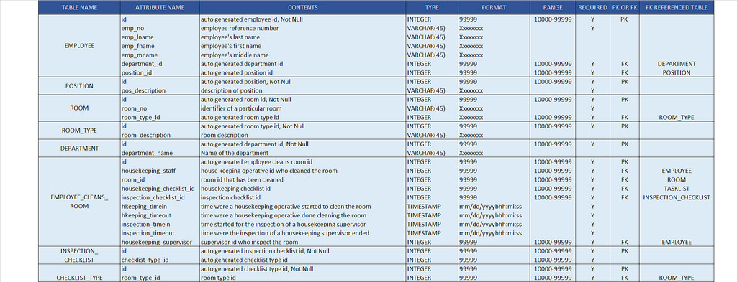

Appendix A: Glossary
Qr Code | for automated room inspection time-in and time-out recording.
Inspection Checklist | A list of furnitures/items that will be a medium on inspecting cleaned rooms.
Web page | a hypertext document connected to the World Wide Web.
Housekeeping Inspector | A person in charge of scrutinizing and evaluating inspection reports.
Browser | used to access the world wide web and view reports
Housekeeping Manager | Person who is in charge of reviewing guestroom inspection reports on the web interface.

Appendix B: Analysis Models
Dataflow Diagram(DFD) Level 1

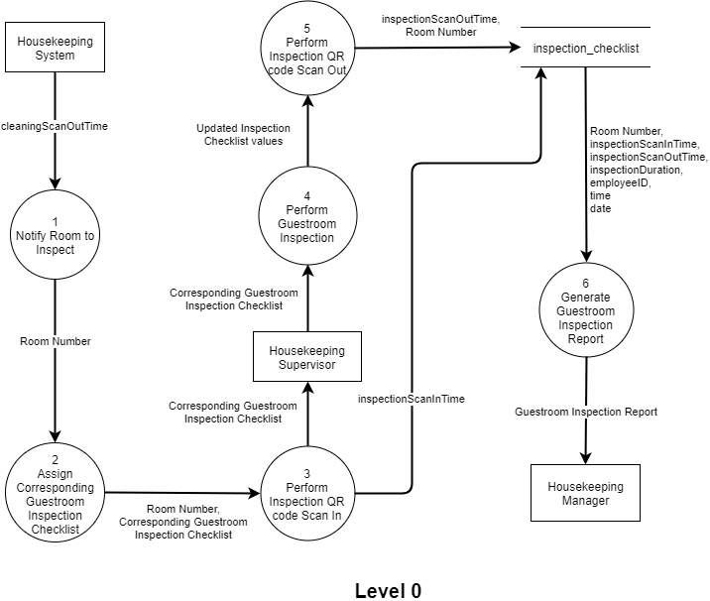

Appendix C: To Be Determined List
- Design and Implementation Constraints

